VICTOR VALLEY GEM AND MINERAL CLUB
invites you to the 48th Annual

Stoddard Wells Rockhound Tailgate
Victorville, CA

Friday – Sunday, March 8th – 10th, 2024
9:00 am to 5:00 Daily
EVERYONE IS WELCOME

Free Event! Free Vendor Spaces
Dry Camping Restrooms
Lots of Rocks Grab Bags
Kids Games Spin the Wheel
Club Gear Water, Coffee, Sod a
Food Truck - Breakfast and Lunch Offerings
All Donations are gladly accepted to help offset expenses
Come Visit us for Handcrafted and faceted Jewelry,
Slabs and Cabs, Findings and Equipment, Minerals and Fossils,
TONS of Rough Material, and more
NO saving spaces, NO competing with VVGMC’s fundraising activities
ie: Food, drinks, spin the wheel, or auctions
For more Information, visit our website at vvgmc.org or
call 760-243-2330 and leave a message
Saturday FAMILY Field Trip: 9am to 1pm
We’ll be collecting Tri-Color marble!
Verde Antique is less than 1 mile from the area

Directions : From I-15 Northbound towards Barstow :
Hwy 15 North THRU Victorville! – EXIT Rt. At 2nd Stoddard Wells Rd at BELL Mtn. EXIT # 157. Turn Left/East at Ramp STOP Sign. STAY On Stoddard Wells Road 4 mi. until next STOP sign at Dale Evans Pkwy. “Tailgate”signs high on NW corner power pole. Check Odometer here! Continue Straight On Stoddard Wells Rd. 7 miles to “Tailgate”. Road becomes a graded dirt road about 4/10 mi. from the Dale Evans Pkwy intersection. Proceed East/NE past “Grange” fork to “Tailgate” site. Cars & RVs can make it w/ease & care. “ Tailgate ”signs along route.

See You THERE ! Rain or Shine We’ll be There !
Sponsored by the Victor Valley Gem & Mineral Club
For more details visit Club Website at www.vvgmc.org or call (760) 243-2330
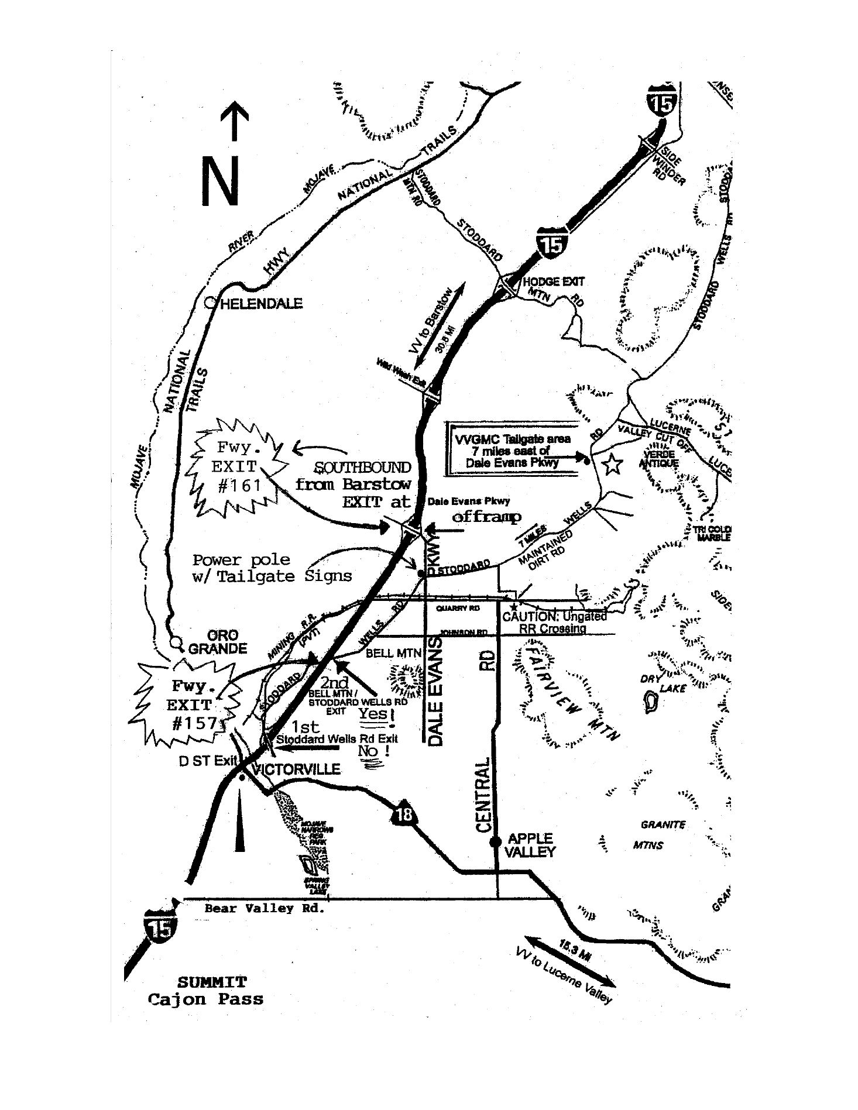
GPS 34.671852347, -117.117133037

