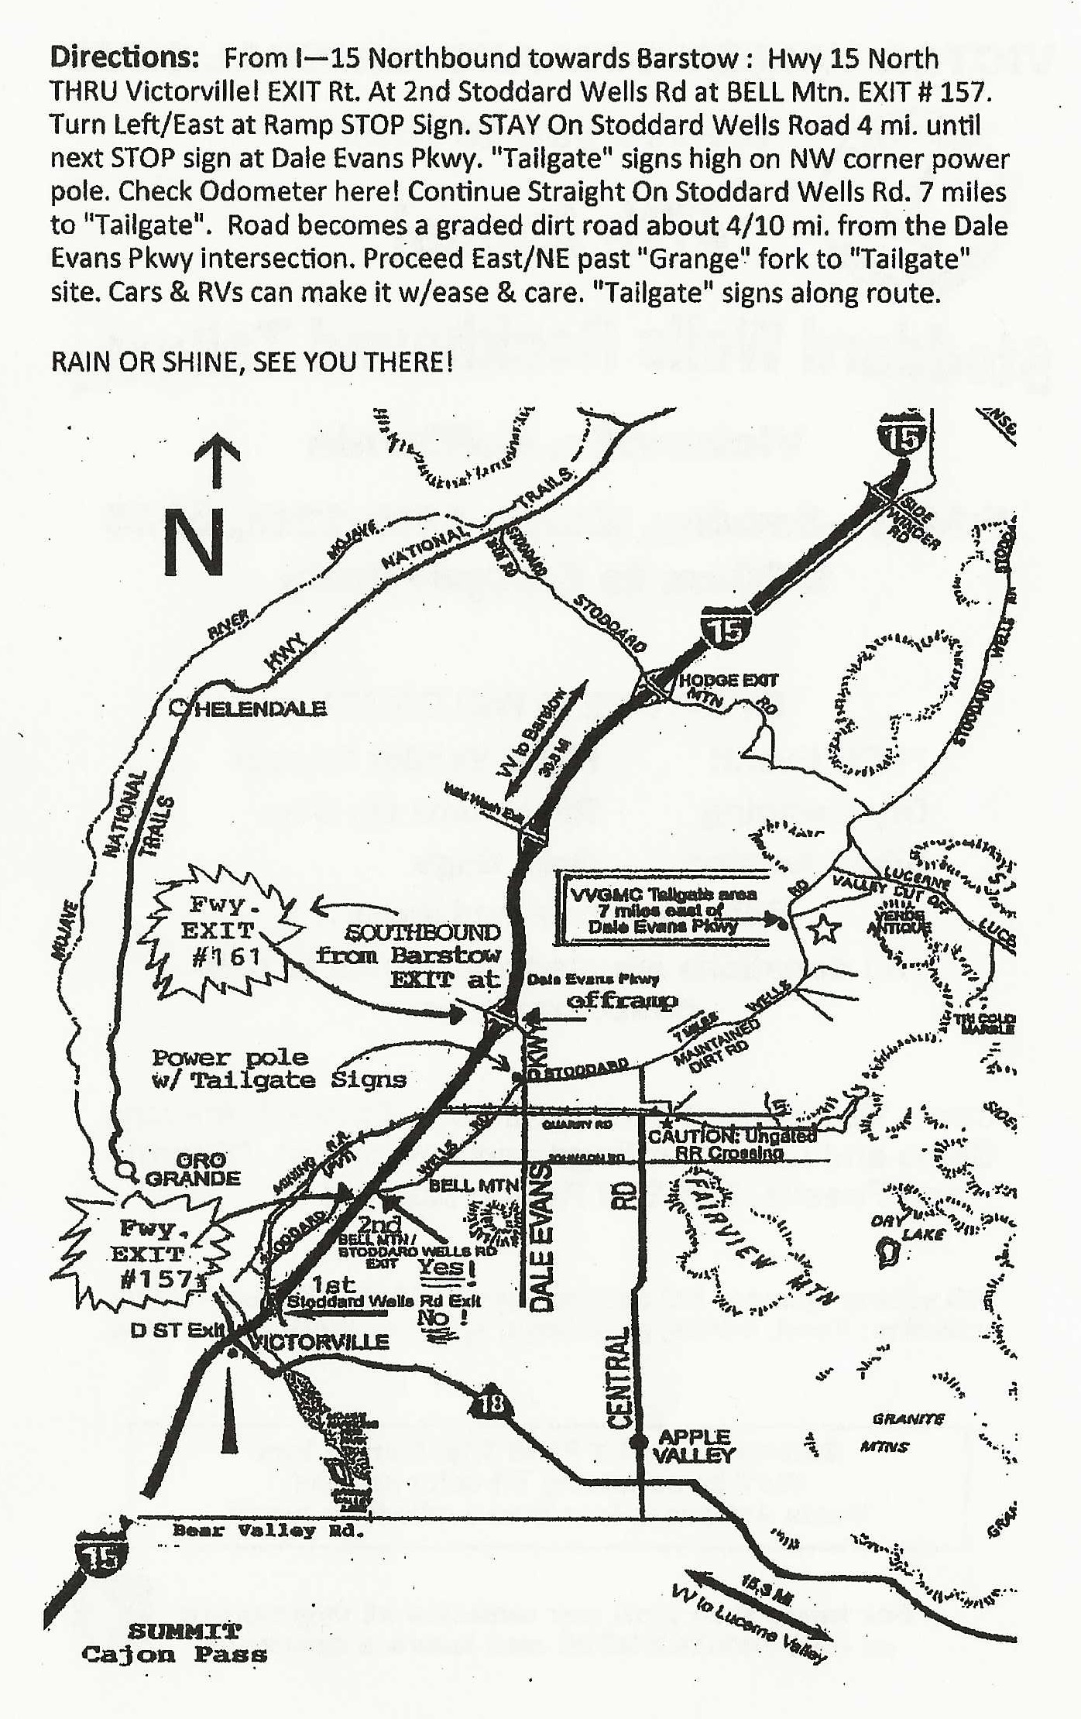

**VICTOR VALLEY GEM AND MINERAL CLUB**

**Invites you to the**

**48th Annual**

**Stoddard Wells Rockhound Tailgate**

**Victorville, California**

**Friday – Sunday, March 8th – 10th, 2024**

**9:00 am to 5:00 Daily**

**EVERYONE IS WELCOME**

**Free Event! Free Vendor Spaces**

**Dry Camping Restrooms**

**Lots of Rocks Grab Bags**

**Kids Games Spin the Wheel**

**Club Gear Water, Coffee, Soda**

**Food Truck - Breakfast and Lunch Offerings**

**All Donations are gladly accepted to help offset expenses**

***Come Visit us for Handcrafted and faceted Jewelry,***

***Slabs and Cabs, Findings and Equipment, Minerals and Fossils, TONS of Rough Material, and more***

*NO saving spaces, NO competing with VVGMC’s fundraising activities*

*ie: Food, drinks, spin the wheel, or auctions*

**For more Information, visit our website at vvgmc.org or**

**call 760-243-2330 and leave a message**

**Saturday FAMILY Field Trip: 9am to 1pm**

**We’ll be collecting Tri-Color marble!**

**Verde Antique is less than 1 mile from the area**

**GPS 34.671852347, -117.117133037**