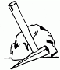
The Victor Valley Gem and Mineral Club
15056-B Seventh Street
Victorville, CA 92395-3811
760 243-2330

