This Planet Really Rocks!

 | What is a Rock?

Fascinating Fact

Rocks found on the moon have some of the same compositions as rocks found on earth.


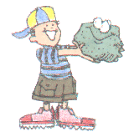
Can you guess? What is something that you see everyday...no matter where you go or where you look? They might be little or big. You might even see them around the neck of a little kid. You guessed right! ROCKS!

Rocks are everywhere. They have been on the earth over four billion years. The rock you see might have once been part of a magnificent mountain or spectacular cave. It could have even been stomped by a dinosaur. Rocks are a fascinating way to discover information about the history of the earth.
Most rocks are made of minerals. However, all rocks are not the same. That is why rock collecting is so interesting and fun. Every rock has its own story.
Rocks can be put into three basic rock types: igneous, sedimentary, and metamorphic. How a rock is formed determines which group it is placed in.
To learn more about rocks and minerals, click on next below:

Igneous Rocks

Sedimentary Rocks

Fascinating Fact
Seventy percent of all the rocks on earth are sedimentary rocks.


The earth's surface is constantly being eroded. This means that rocks are broken up into smaller pieces by weathering agents such as wind, water, and ice. These small pieces of rock turn into pebbles, gravel, sand, and clay. They tumble down rivers and streams. These pieces settle in a new place and begin to pile up and the sediments form flat layers. Over a long period of time, the pieces become pressed together and form solid rock called sedimentary rock. Most sedimentary rocks form under water. Most of the earth has been covered by water some time in the past. 70% of the earth is covered by water now. So sedimentary rocks are common all over the world. Sedimentary rocks are often rich in fossils.
Sediments can harden into sedimentary rock in two ways.
pressure-As layer after layer of sediments are deposited, the lower layers are pressed together tightly under the weight of the layers above.
cementing-Some sediments are glued together by minerals dissolved in water.
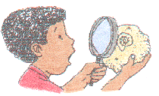
Some examples of sedimentary rocks are sandstone, limestone, conglomerate, and shale. Sandstone is formed from grains of sand pressed tightly together. Sandstones are very common rocks. They are formed from the sand on beaches, in riverbeds, and sand dunes. Sandstones are usually made of the mineral quartz. Limestone is formed from tiny pieces of shells of dead sea animals that have been cemented together. Conglomerate contains sand and rounded pebbles that have also been cemented together. Shale is formed from mud or clay that has been pressed together. Shale forms in quiet waters such as swamps and bogs. Sedimentary rocks are easy to identify because you can actually see the layers.
Below is a summary of the major characteristics of sedimentary rocks.
Classified by texture and composition
Often contains fossils
May react with acid
Often has layers, flat or curved
Usually composed of pieces cemented or pressed together
Has great color variety
Particle size may be the same or vary
Usually has pores between pieces
May have cross-bedding, mud cracks, worm burrows, raindrop impressions
Here's a checklist of some common sedimentary rocks and their characteristics. Look for these same characteristics in the rocks you find, and you'll be well on your way to becoming a rockhound.

Some Common Sedimentary Rocks
Name | Image | Color | Composition
Sandstone |  | Red or Gray | Sand grains cemented together
Limestone |  | White to Gray | Calcite and sometimes fossils
Shale |  | Dark Gray | Compacted mud
Conglomerate |  | Different Colors | Rounded cobbles and pebbles cemented together

Metamorphic Rocks

Fascinating Fact
The oldest known rock lies in Canada. The Acasta gneiss, a metamorphic rock, is 3.96 billion years old.


Heat and pressure can change many things. They can even change rocks. The name for rocks that has been changed is metamorphic (met uh MOR fik) rocks. Metamorphic comes from Greek words meaning "change" and "form".

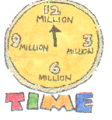
Metamorphic rocks form deep in the earth where high temperature, great pressure, and chemical reactions cause one type of rock to change into another type of rock. Metamorphic rocks begin to form at 12-16 kilometers beneath the earth's surface. They begin changing at temperatures of 100 degrees Celsius to 800 degrees Celsius. If you squeeze and heat a rock for a few million years, it can turn into a new kind of rock.
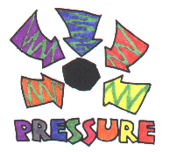
Where does the heat come from? The heat comes from magma. Where does the pressure come from? The pressure comes from layers of rock piled on top of layers and layers of rock. The layers on the bottom get squeezed. The thicker the layers, the more pressure there is.
Some examples of how metamorphic rocks were changed:
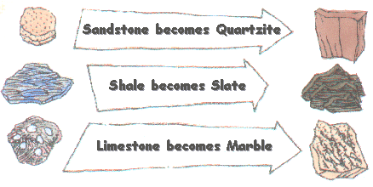
Below is a summary of the major characteristics of metamorphic rocks.
Classified by texture and composition
Rarely has fossils
May react with acid
May have alternate bands of light and dark minerals
May be composed of only one mineral, ex. marble & quartzite
May have layers of visible crystals
Usually made of mineral crystals of different sizes
Rarely has pores or openings
May have bent or curved foliation
Here's a checklist of some common metamorphic rocks and their characteristics. Look for these same characteristics in the rocks you find, and you'll be well on your way to becoming a rockhound.

Some Common Metamorphic Rocks
Name | Image | Color | Texture
Gneiss |  | Pink/Gray | Foliated
Marble |  | Light Colored | Unfoliated
Quartzite |  | Light Colored | Unfoliated
Slate |  | Dark Gray to Black | Foliated
To learn more about rocks and minerals, click next below:

Rock Cycle

Fascinating Fact
Up to 100,000 tons of rock a year fall to earth from space. The largest meteorite in the world lies in the ground in Africa and weighs more than 60 tons.

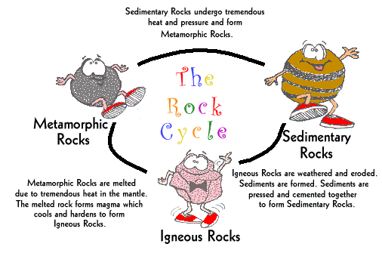
Did you know that rocks are constantly being recycled? Recycle means to take something old and change into something new. So some of these old rocks that have been around for more than four billion years are being changed into different rocks. Of course, that doesn't happen over night. It takes millions of years. To better understand how this happens, let's take a journey through the rock cycle.
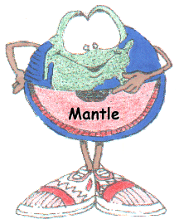
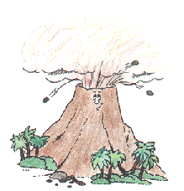
First, our journey begins in the mantle. Here we see some red hot magma that is being pushed up towards the crust. Some of this magma creeps into the cracks of the volcano; while, the rest is forced out of the top of the volcano. Once the magma is out of the volcano, it is called lava. The lava cools and forms igneous rocks.
Then some of the igneous rocks roll down the mountains formed by the volcanoes and eventually end up in the ocean. As they roll, bits and pieces of the igneous rocks are broken and form sediments. Layer after layer of sediments are pressed and cemented together forming sedimentary rocks.
Some of the sedimentary rocks on the very bottom get hot because of the pressure and change to metamorphic rock. When the metamorphic rock is buried deeper, it gets hotter and melts. Once again, it becomes magma and may eventually be pushed up and out of a volcano.
The rock cycle begins all over again!

What is a Mineral?

Fascinating Fact
The elements oxygen, silicon, aluminum, iron, magnesium, calcium, potassium, and sodium make up 99 percent of all minerals on Earth.


Do you know the difference between a rock and a mineral? Minerals are the building blocks of rocks. Here are some of the basic characteristics of minerals to help you understand what they are:
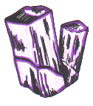
Minerals are inorganic; they are not alive and they are not plants or animals. An example of a rock that is not a mineral is coal. Coal is a substance formed from decayed plants and animals. Therefore, coal is not considered a mineral.
Minerals are found in the earth or are naturally occurring substances. They are found in dirt, rocks, and water. They are not made by man.
Minerals are chemical substances. Some minerals like gold or silver are made of only one element. Other minerals, like quartz and calcite, are combinations of two or more elements.
Minerals always have the same chemical makeup. For example, quartz will always consist of one part silicon (an element) two parts oxygen (another element).
Minerals are usually solid crystals. They have a number of flat surfaces in an orderly arrangement. For example, a crystal of quartz is always hexagonal because of the way the atoms of silicon and oxygen join together.
About 2,000 minerals have been found. Oxygen is part of many minerals. Minerals containing oxygen make up almost half of the earth's crust. Quartz is a common mineral. Other common minerals are feldspar, mica, and horneblend. Many rocks are made of these common minerals.
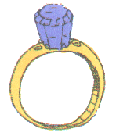
Some minerals are rare and expensive. They are called gems . Diamonds, rubies, and emeralds are good examples of such minerals. Gold and silver are also minerals. Together, these natural substances are used to make beautiful jewelry.
To learn more about rocks and minerals, click on next below.

How are Minerals Identified?

Fascinating Fact
The largest topaz crystal was found in Brazil in 1940. It weighs 596 pounds. It is on display in the American Museum of Natural History in New York.

You are probably wondering how scientists have identified over 2,000 minerals. Well, minerals have certain properties, or characteristics, that help to identify them. Minerals can be identified by their color, luster, streak, cleavage, hardness, specific gravity, and even by their chemical composition. Below you will find a table of some of these properties. Also, included are some examples of minerals that help explain these properties. There are also links to webpages that have additional information about each of the properties described below. Hopefully, this information will help you to become a good mineral detective.
GOOD LUCK!

Color
Color is not always a good clue to the identity of a mineral. Many minerals are found in several colors and many minerals have extra chemicals in them that give them an unexpected color. Also, weathering may change the color of the mineral. | Example-quartz comes in various colors: rose, milky, clear

Luster
Luster is the way a mineral reflects light. Minerals can be described as metallic, pearly, glassy, silky, greasy, brillant, or dull. | For example, diamonds are brillant. Talc has a greasy luster, quartz has a glassy luster, and gypsum has a pearly luster. Pyrite or fool's gold, as it is sometimes called, has a metallic luster.

Streak
This is the color of the streak made by rubbing a mineral across a hard, rough surface like a bathroom tile. | An example is pyrite which is a brassy, yellow color. However, it makes a greenish, black streak when rubbed across a rough surface. You will need a field guide to rocks and minerals to tell you what color streak a mineral makes.

Cleavage
Cleavage is when certain minerals break in a definite way. | For example, galena cleaves into little cubes. Mica cleaves into thin sheets. Calcite cleaves into slanting bricks. Feldspar breaks into little steps. Quartz cleaves into irregular chunks.

Hardness
Hardness is measured by seeing how easy it is to scratch a mineral. | For example, talc, the softest mineral known, can be scratched with a fingernail. Diamond, the hardest mineral, can scratch all the other minerals but cannot be scratched by them. A German mineralogist, Friedrich Mohs, developed a standard scale of hardness in 1822. His scale is so easy to use that it is still in use today.

Specific Gravity
Specific gravity of a mineral is its relative weight compared to the weight of an equal volume of water. It determines the density of the mineral. | Two minerals may be the same size, but their weight may be very different. Water has a specific gravity of 1. If a mineral has a specific gravity less than 3, it is considered a "light" mineral, between 3 and 5 - "average", and more than 5 - "heavy". Minerals with a metallic luster are usually "heavy".

Top of Form

Moh's Hardness Scale
Hardness | Mineral | Description
1 | Talc | Fingernail scratches it easily.
2 | Gypsum | Fingernail scratches it.
3 | Calcite | Copper penny scratches it.
4 | Fluorite | Steel knife scratches it easily.
5 | Apatite | Steel knife scratches it.
6 | Feldspar | Steel knife does not scratch it easily, but scratches glass.
7 | Quartz | Hardest common mineral. It scratches steel and glass easily.
8 | Topaz | Harder than any common mineral.
9 | Corundum | It scratches Topaz.
10 | Diamond | It is the hardest of all minerals.

Some Common Minerals and Their Properties
Name | Color | Streak | Luster | Hardness | Other Properties
Graphite | Black | Black | Metallic | 1 | Crystals are rare.
Mica | Colorless | White | Pearly | 2.5-3 | Flakes into sheets
Halite | Colorless | White | Glassy | 2.5 | Salty taste
Galena | Gray | Gray | Metallic | 2.5-3 | Crystal Cubes
Calcite | Colorless | White | Glassy | 3 | Crystalline
Magnetite | Black | Black | Dull | 5.5-6.5 | Magnetic
Pyrite | Golden | Black | Metallic | 6-6.5 | Looks like gold
Feldspar | Various | White | Glassy | 6-6.5 | Two cleavages
Quartz | Various | White | Glassy | 7 | Round fracture
Corundum | Gray | White | Glassy | 9 | Crystalline

Uses of Rocks and Minerals

Fascinating Fact
The most common mineral on earth is quartz.

Have you ever wondered what the world would be like without rocks? You may not know it, but if we took all the rocks away, we would have a miserable life. We use rocks for roads, metals, jewelry, tombstones, building materals, cosmetics, and many, many more things. Most of the famous sculptures of the world are made from blocks of stones such as granite and marble. Did you know that the Great Wall of China and the Taj Mahal are made out of rocks? We also collect rocks as a hobby. If we did not have rocks, this earth would be pretty empty. Who wants an empty earth? Not me!
To better help you understand the importance of rocks, study the table below of some the most commonly used rocks and minerals.

The Importance of Rocks and Minerals
Name | Type of Rock | Use
Basalt | Igneous | Used in road building  materials
Calcite | Mineral | Used in cements and mortars and the production of lime
Granite | Igneous | Used for buildings, monuments, and tombstones
Marble | Metamorphic | Used in building, floors, tile in bathrooms
Obsidian | Igneous | Used in making arrowheads and knives
Pumice | Igneous | Used in scouring, scrubbing, and polishing materials
Quartz | Mineral | Used in making glass, electrical components, and optical lenses
Sandstone | Sedimentary | Used in the building  industry for houses
Slate | Metamorphic | Used for roofs, chalkboards, and patio walks

Rock Jokes

Now for some fun! Here are some rock "puns" written by our very own Thinkquest Team. We would like for you to share your "rock jokes" with us and we will post them with your name, age, and location on this page. So get busy and email us your jokes. Have Fun!
- What does a rock want to be when it grows up?
- What do you call a dog who collects rocks?
- What do you do to a baby rock?
- What is a rock's favorite kind of music?
- Where do rocks sleep?
- How do rocks wash their clothes?
- What is a rock's favorite transportation?
- What is a rock's favorite cereal?
- Where is a rock's favorite golf course?
- What is a rock's favorite television show?

Answers

- A Rock Star
- A Rockhound
- Rock it
- Rock 'N Roll
- Bedrock
- On the rock cycle
- A rocket
- Cocoa Pebbles
- Pebble Beach
- "Third Rock from the Sun"

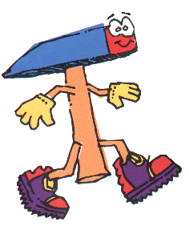 | Ryan's  Rockhounding Story

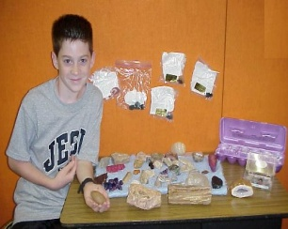

Hi! My name is Ryan and I am eleven years old. I am in the sixth grade at Vidor Middle School. I started rock collecting at the ripe young age of seven. My Grandma bought me a special crystal that set me on my rockhounding adventures. I have been to South Dakota, Oregon, and Arizona looking for rocks. My mom has even been to France and brought me back many rocks to add to my more than 200 rocks in my collection.
I keep my rocks just about everywhere. I keep then in my room on shelves, in display cases, and even outside in my rock garden. The best thing about rock collecting is that it is a very good hobby. It doesn't turn you into a couch potato. Most importantly, it's fun! Some rocks are valuable and hard to find. That is why I think it will be a lifelong hobby for me.
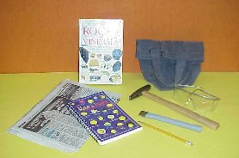
Now if you want to look for rocks and minerals, you must have the right tools. If you don't already have some of these things around your house, you should be able to buy them at your local hardware store or from a rock and mineral dealer.

Rockhounding Tools
Tool | Description
Rock Hammer | Should have a square head and a pointed end for breaking off small rock specimens to bring home
Chisel | A good tool for helping to loosen and break off rock pieces
Magnifying Glass | To help you take a closer look at the different mineral crystals and other structures in the rocks.
Safety Goggles | To protect your eyes from rock fragments that may fly up when you are loosening rock and mineral specimens
Notebook and Pencil | To jot down notes about the rock specimens that you are collecting - the date and place found
Newspaper | To wrap each specimen so that the rocks don't hit against each other and break
Bucket or Canvas Bag | For carrying your rock and mineral specimens home in
Now that you have all the right tools to get started rock hunting, you are probably asking yourself "where should I look for specimens?" Look for areas where there is exposed rock. Along stream beds, hillside ledges, and road cuts are good places to begin your rockhounding adventures. If you know that you will be collecting on someone's private property, ask their permission first. ALWAYS take along a friend. Let your family know where you will be exploring. BE CAREFUL!

Rock Sayings

Did you know that the diamond is the hardest natural substance found on earth?
Did you know that quartz is one of the most common minerals on Earth?
Did you know that marble forms from metamorphosed carbonate rock, most usually limestone?
Did you know that basalt is the most common rock on Earth?
Did you know that breccia is a rock composed of generally large, sharp fragments cemented together?
Did you know feldspars make up more than 50% of the Earth's crust?
Did you know the first recorded use of turqouise dates back to 5000 BC in Mesopotamia, where people used the gemstone to make beads?
Did you know lapis lazul is treasured for its rich blue color and is often used in jewelry? Did you also know that ancient Eqyptians used powdered lapis lazul as eye shadow?
Did you know jade because of it's toughness has been used for many cultural things like hammers, fish hooks, and stone axes.
Did you know that rubies are one of the most popular gemstones today.
Did you know that the first geologist on the moon was Harrison Schmitt who was part of the Apollo 17 mission? From the rock samples he collected, scientists have been able to learn many things about the moon.
Did you know that the Earth is approximately 4.8 billion years old?
Did you know that gold is so soft and easily worked that you could roll an ounce of it into a hair-thin wire 50 miles long?
Did you know that the biggest pure-gold nugget was found in Australia in 1869 and weighed 156 pounds?
Did you know that platinum is so rare that two million pounds of ore may contain only one pound of metal?
Did you know that geodes are dull balls of igneous or sedimentary rock on the outside, but contain beautiful crystals on the inside?
Did you know that meteorites, rocks from space, help scientists learn about the solar system and are very valuable, too?
Did you know that the Taj Mahal built between 1632 and 1654 in India is made entirely out of marble?

Bottom of Form

