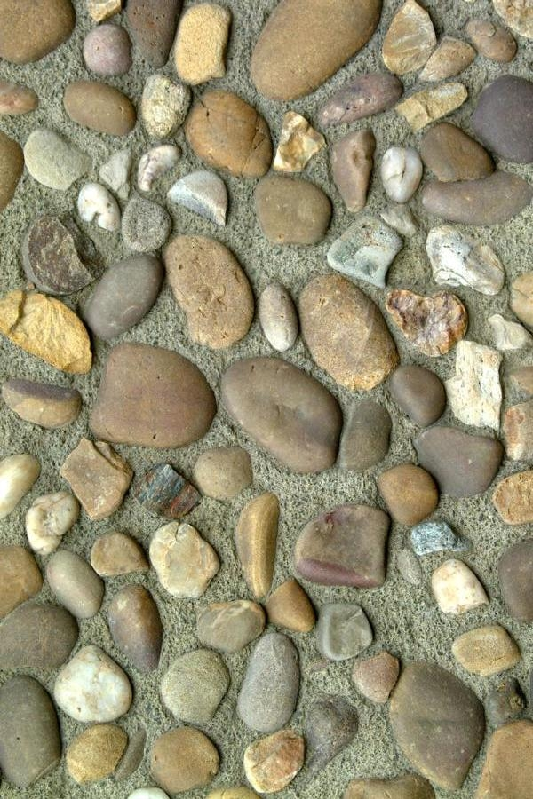

**24th Annual Gem Show**

San Bernardino County Fairgrounds in Victorville

Sponsored by Victor Valley Gem and Mineral Club

**November 13-14, 2010**

Saturday 9-5, Sunday 9-4

Be our guest and bring this coupon with you to receive a polished tumbled stone

Many Vendors

findings, rough rocks, books, jewelry, slabs, cabs, minerals, equipment, and more

**24th Annual Gem Show**

San Bernardino County Fairgrounds in Victorville

Sponsored by Victor Valley Gem and Mineral Club

**November 13-14, 2010**

Saturday 9-5, Sunday 9-4

Be our guest and bring this coupon with you to receive a polished tumbled stone

Many Vendors

findings, rough rocks, books, jewelry, slabs, cabs, minerals, equipment, and more

**24th Annual Gem Show**

San Bernardino County Fairgrounds in Victorville

Sponsored by Victor Valley Gem and Mineral Club

**November 13-14, 2010**

Saturday 9-5, Sunday 9-4

Be our guest and bring this coupon with you to receive a polished tumbled stone

Many Vendors

findings, rough rocks, books, jewelry, slabs, cabs, minerals, equipment, and more

**24th Annual Gem Show**

San Bernardino County Fairgrounds in Victorville

Sponsored by Victor Valley Gem and Mineral Club

**November 13-14, 2010**

Saturday 9-5, Sunday 9-4

Be our guest and bring this coupon with you to receive a polished tumbled stone

Many Vendors

findings, rough rocks, books, jewelry, slabs, cabs, minerals, equipment, and more